Guía Nº2 JOBS
English

Nombre: |  | Curso: | I M A | Fecha

-Instructions;
1.- Elabora en tus palabras la mejor definición para cada occupation or job.
2.- Lee el texto y contesta las preguntas.
3.- Envía solo las respuestas en un archivo;Word,pdf o foto a paula.aracena@elar.cl señalando;
-Nombre
-curso
-Nº de guía
Se recomienda dictionary
https://www.ldoceonline.com/es-LA/

Objetivos:
A09. Demostrar comprensión de ideas generales e información explícita en textos adaptados y auténticos simples, en formato impreso o digital, acerca de temas variados (como temas de interés de los y las estudiantes, temas de otras asignaturas, del contexto inmediato, de actualidad e interés global, de otras culturas y algunos temas menos conocidos) y que contienen las funciones del año.
Contenidos; Jobs

Item I.-Vocabulary in context

I.- Describe in your words the following occupations or Jobs (18 points)

Read the text and answer the questions
The Most Extraordinary Jobs

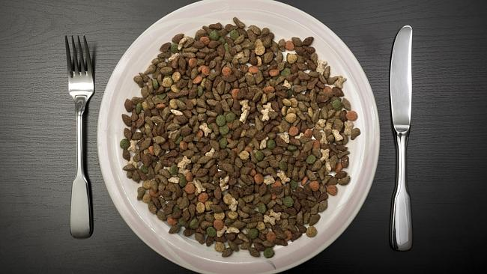
1. Pet Food Tester
Yes, it's a thing, and yes it's totally gross.
But as the owner of pet food company Huds and Toke, Mark Gooley, says, "If you wouldn't put it in your mouth, don't you dare expect your dog to eat it."
Mr Gooley eats dog food for a living. He eats everything from doggie treats and chewy bones to liver mixture
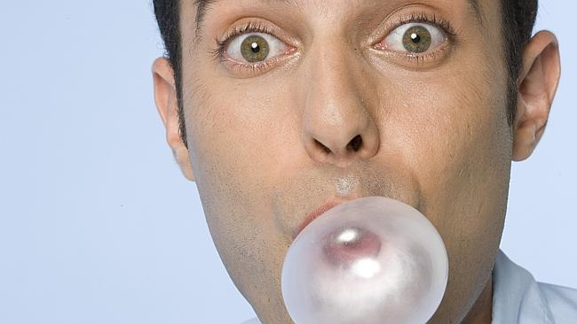
2. Gumologist
A lot of hard work goes into creating the perfect piece of chewy.
Just ask Jesse Kiefer, who works as a Gumologist for Cadbury Schweppes.
Kiefer has to get the flavour just right, which isn't easy with some combos like strawberry and lime - which he says don't complement each other that well.
3. Waterslide Tester
Monday morning definitely seems a lot more enticing if you get to spend your working week slipping down water slides. Especially come summer.
And water slides are usually placed in massive theme parks. Imagine getting to spend your lunch break on a rollercoaster, and eating a hot dog for lunch.
Working holiday, am I right?
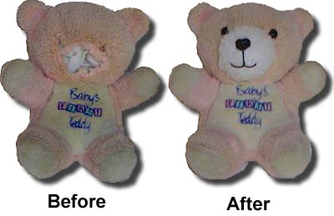
4. Teddy Bear Repair Technician
Kids get really emotional about their toys. Remember when your favourite toy lost an arm, or suffered a similar life-threatening injury? It was devastating.
But now there's a special technician who can come to the rescue.
The Build-A-Bear Workshops have a Teddy Bear Repair Technician who is hired to repair those much-loved teddy bears and get them back to their cuddly, intact, lovable selves.
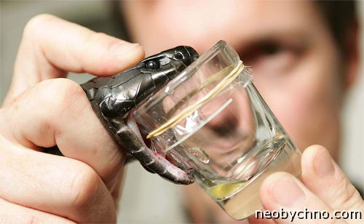
5. Snake Milker
Snake venom is powerful stuff. It can be turned into drugs to treat all kinds of conditions, including a poisonous snake bite.
But some brave soul needs to collect that venom by hand. They gently expose the snake's fang and squeeze out the deadly juices.
"The only difference between me and any other company in the world that produces something is that the means of production here can kill you...and wants to," Alabama snake milker Ken Darnell says.

6. Laughter therapist
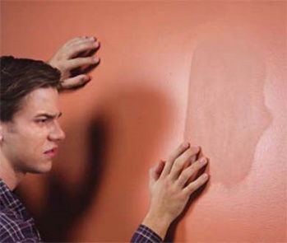
They say it takes more muscles to frown than it does to smile. If that’s true then a career as a laughter therapist should be an easy ride. In this job a laughter therapist must do their best to make people laugh their way to a better life. Perfect for any budding clowns out there!

7. Paint Watcher
You may have heard some people say they’d “rather watch paint dry” than do something they don’t want to do. Well, if they really mean it the opportunity is there – studying the drying time and effects of paint as a full-time job for a paint manufacturer.

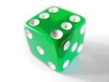
8. Dice inspector
In the gambling world, millions can be lost at the roll of a faulty dice. With that in mind, the job of a dice inspector is an important one, making sure each die is in proportion, with all the right angles and blemish free.

Item II.-Discussion Questions (12 points)
- Which job did you find the most extraordinary/usual/exciting/boring/useful?
___________________________________________________________

- What other extraordinary jobs have you heard of?
_________________________________________________________________

- What kind of person would do things like that for a living?
_________________________________________________________________

- What qualities are required for each of these jobs?
_________________________________________________________________

- Which of these jobs would you be able to do? Why?
_________________________________________________________________

- Which of them you would never agree to do even if offered lots of money?”Why?

__________________________________________________________________

Item III.-ACTIVITY. Look up for the following words in Spanish and write down the definitions in the blanks.
(24 points)

- Tester___________________  - Gross____________________  - Dare____________________  - For a living____________________  - Chewy____________________  Flavor____________________  complement____________________  enticing____________________  slides____________________  rollercoaster___________________  suffered____________________  life-threatening injury____________________ | devastating. ________________  to the rescue. _______________  Cuddly____________________  Venom____________________  Poisonous___________________  fang____________________  budding____________________  rather watch paint dry____________________  gambling____________________  faulty____________________  angles____________________

IV. - Choose the best option for each definition:

1. - Marked by defect.  - Slides  - Flavour  - Faulty  d) Fang | 2.- A long sharp tooth  - Slides  - Flavour  - Faulty  - Fang
3.- to have sufficient courage:  - Venom  - gambling  - Dare  d) Budding | 4. - Inspiring disgust or distaste.  - Venom  - Poisonous  - Gross  - Gambling
5. - A substance that is poisonous.  - Venom  - gambling  - Dare  - Budding | 6. - To crush, grind, or gnaw (something, such as food) with or as if with the teeth .  - Flavor  - Fang  - Dare  - Chew
7- An elevated railway (as in an amusement park) constructed with sharp curves and steep inclines on which cars roll.  - Chewy  - Flavor  - Rollercoaster  - Slides | 8-To play a game for money or property.  - Budding  - Dare  - Gambling  - Venom
9. A person who tests something, especially a new product  - Chewy  - Flavor  - Gross  d) Tester | 10. - To free from confinement, danger, or evil.  - Rescue  - Gambling  - Devastating  - Angles
11-The quality of something that affects the sense of taste.  - Chewy  - Flavor  - Gross  d) Tester | 12.- A channel or track on which something is slide:  - Chewy  - Flavor  - Rollercoaster  - Slides

